Project Requirements Analysis:

System Users:

1. ADMIN  
2. MODERATOR   
3. BLOGGER   
  
Features:  
  
A. COMMON  
1. Log in to the system.  
2. Logout from the system.  
3. Update own profile.  
4. Change password.  
5. Retrieve forgotten password.  
6. View blogs and comments.  
7. See bloggers profile and posts.  
8. Can view announcements   
  
B. ADMIN  
1. Approve pending registrations.  
2. Add new moderators.  
3. Update users (ADMIN, MODERATOR) details.  
4. Restrict users (All) login.  
5. Add announcements.  
6. View users (BLOGGER) feedbacks.  
7. View moderator's notified issues.  
  
C. MODERATOR   
1. View reported blogs list.  
2. View reported comments list.  
3. Delete reported post.  
4. Delete reported comments.  
5. Notify issues to admin.  
  
D. BLOGGER   
1. Add new blogs.  
2. Update own blogs.  
3. Delete own blogs.  
4. Report blogs.  
5. Report comments of own blogs.  
6. Deactivate own account.  
7. Register to the system.  
8. Give feedbacks.

Entity Relationship Model:

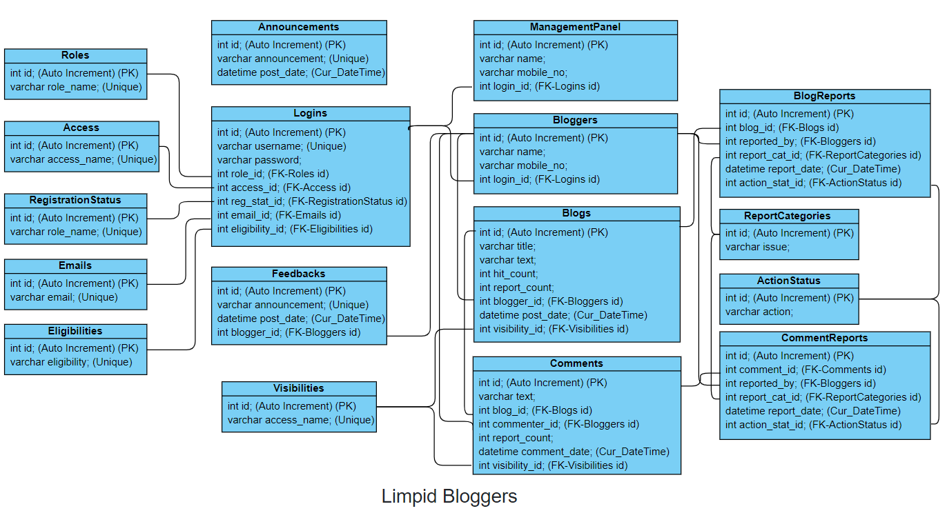

Designed with:

https://online.visual-paradigm.com/app/diagrams/#diagram:proj=0&type=ClassDiagram